No. | INSTRUCTIONS |  | KEY POINTS / CONTACTS
1. | This is done once a bin full of scrap has been removed from the line and placed in the full scrap bin area.  This job is to be completed by a licensed forklift driver. | 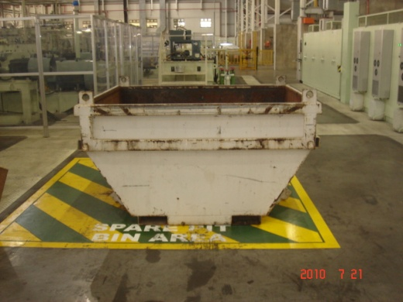 | ENSURE PERSONNAL PROTECTIVE EQUIPMENT (PPE) IS WORN: -  1. HARD HAT  2. STEEL CAP BOOTS  3. GLOVES
2. | Use the 6 ton gas forklift to move the scrap bins.  Slide the forks into the slots at the bottom of the bin.  Tilt and raise the forks to lift the bin off the ground.  FORKS TO BE KEPT LEVEL.  ENSURE FORKS ARE FREE FROM THE LOAD ONCE PLACED. | 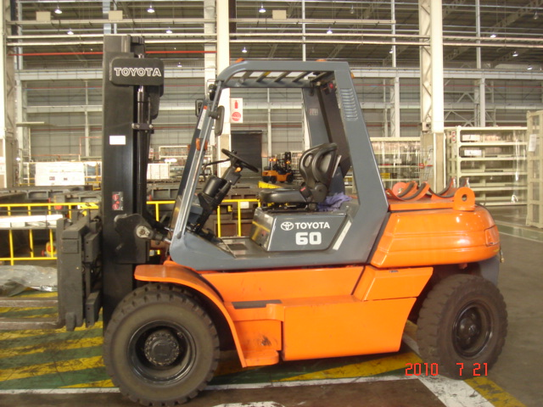 | 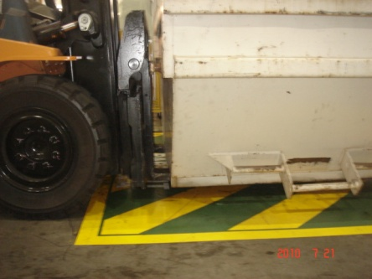
3. | Remove the full bin to the bin storage area outside.  Ensure the steel sliding doors are fully up before driving the forklift through. | 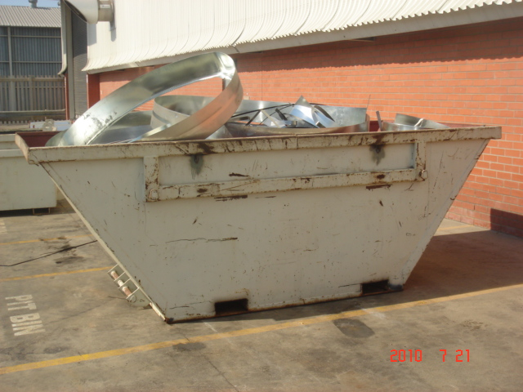 | Maintain speed limit 7km/h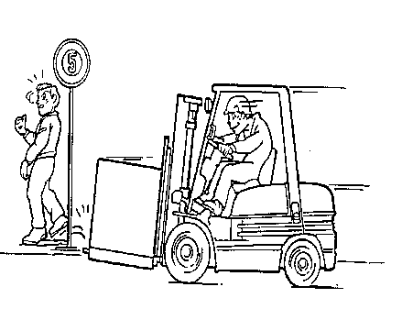
4. | Once the full bin has been offloaded pick up an empty scrap bin and place it in the empty scrap bin area on the line.  Inform your manager that there is a full scrap bin that needs to be replaced with an empty one. |  | 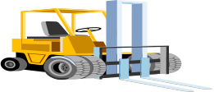  3 METER

